Intro to GitHub: Commands & Basic Functions Guide

What is Git and GitHub?
- Git is a version control system. It tracks changes in your code and allows multiple people to work together without overwriting each other's work.
- GitHub is a cloud platform for hosting Git repositories. It’s where you store your projects online and collaborate with others.

Common Git Workflow
- Clone → Get a copy of a repository from GitHub to your local machine.
- Make changes → Edit/add/delete files locally.
- Commit → Save changes locally with a message describing them.
- Push → Send your committed changes to GitHub.
- Pull → Fetch latest changes from GitHub to your local repo.

Setup Git
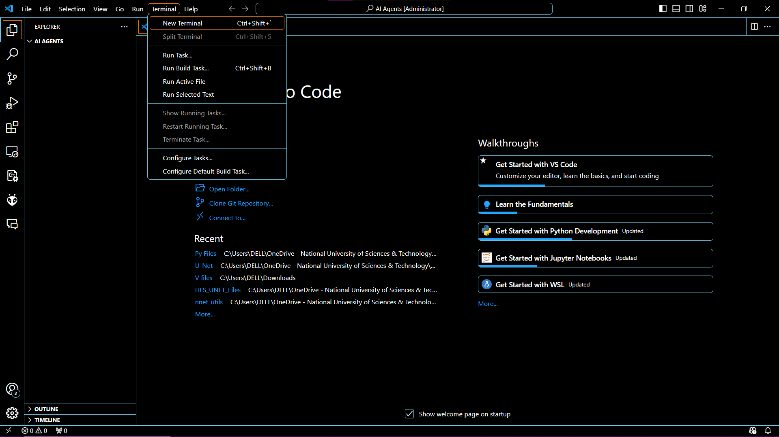
You have to open the terminal and
Syntax:
git config --global user.name "Your Name"
git config --global user.email "you@example.com"
Example with comments: (Everything written with # are comments)
git config --global user.name "Awais-Asghar"
# replace "Awais-Asghar" with your GitHub username
git config --global user.email awaisasghara786@gmail.com
# replace with your email
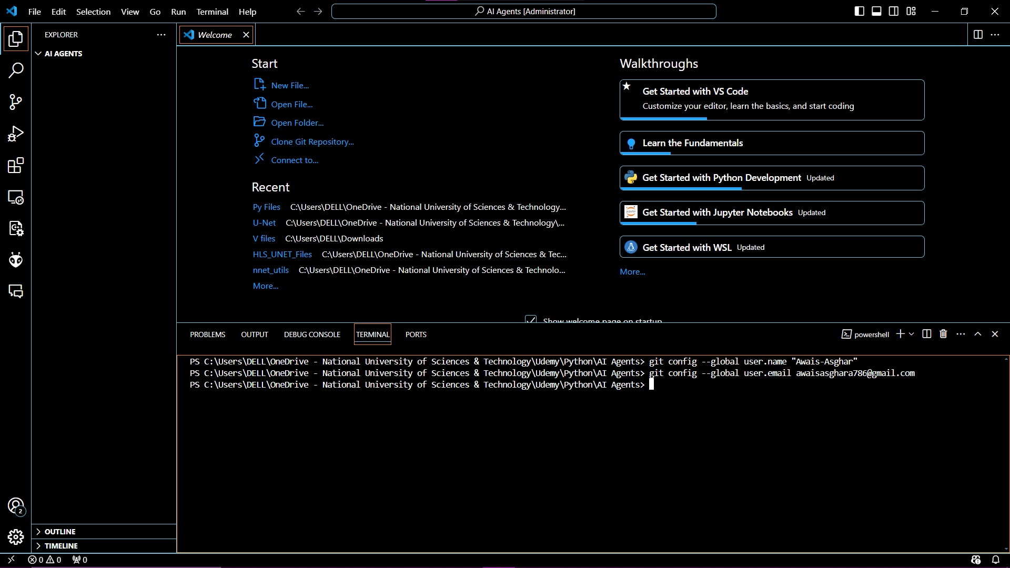
- This sets your identity for all commits.

Forking (On GitHub website)
Steps:
- Go to https://github.com/Awais-Asghar/AI-Agents-From-Idea-to-Deployment
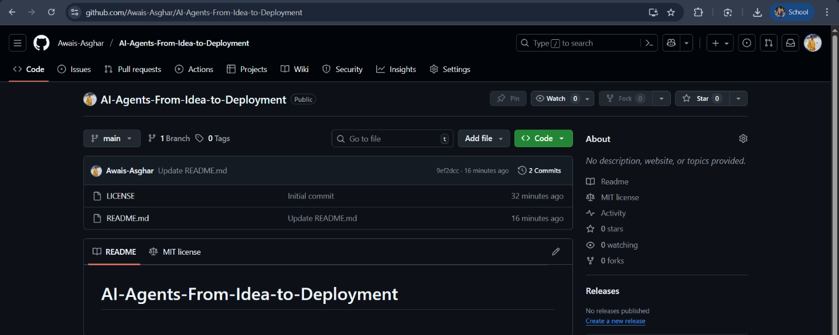
- You will see this type of interface.
- Click Fork → now the repo is copied to your account
Clone your forked repo: Cloning is copying a GitHub repository to your local computer so you can work on it.
git clone https://github.com/your-username/AI-Agents-From-Idea-to-Deployment.git
Comments:
- Replace your-username with your GitHub username.

Cloning a Repository
Syntax:
git clone <repository-url>
Example:
git clone https://github.com/Awais-Asghar/AI-Agents-From-Idea-to-Deployment.git
Comments:
- Replace the URL with your own forked repo if you forked it.
- You can see this GitHub notification if you have set the 2 factor authentication otherwise
- If you do not see these notification then skip these 3 steps.
  - 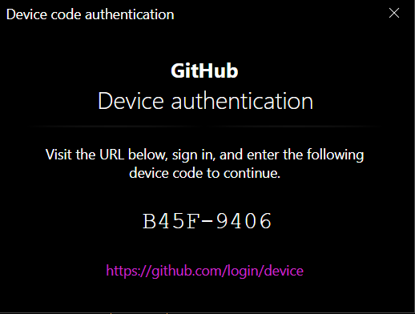
  - 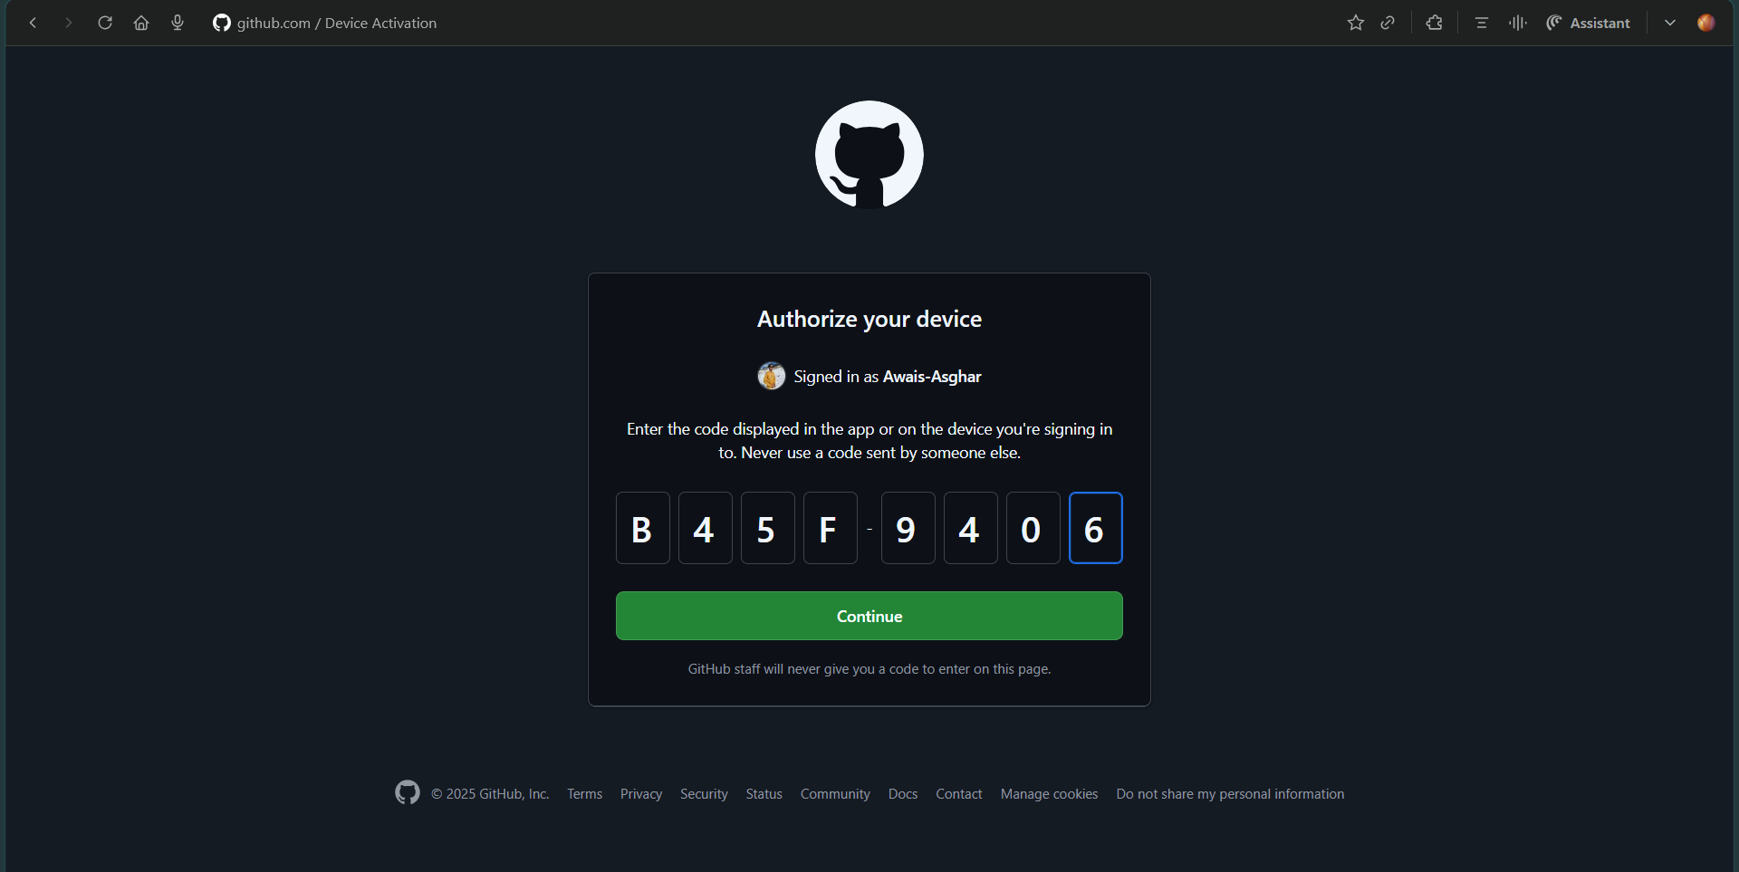
  - 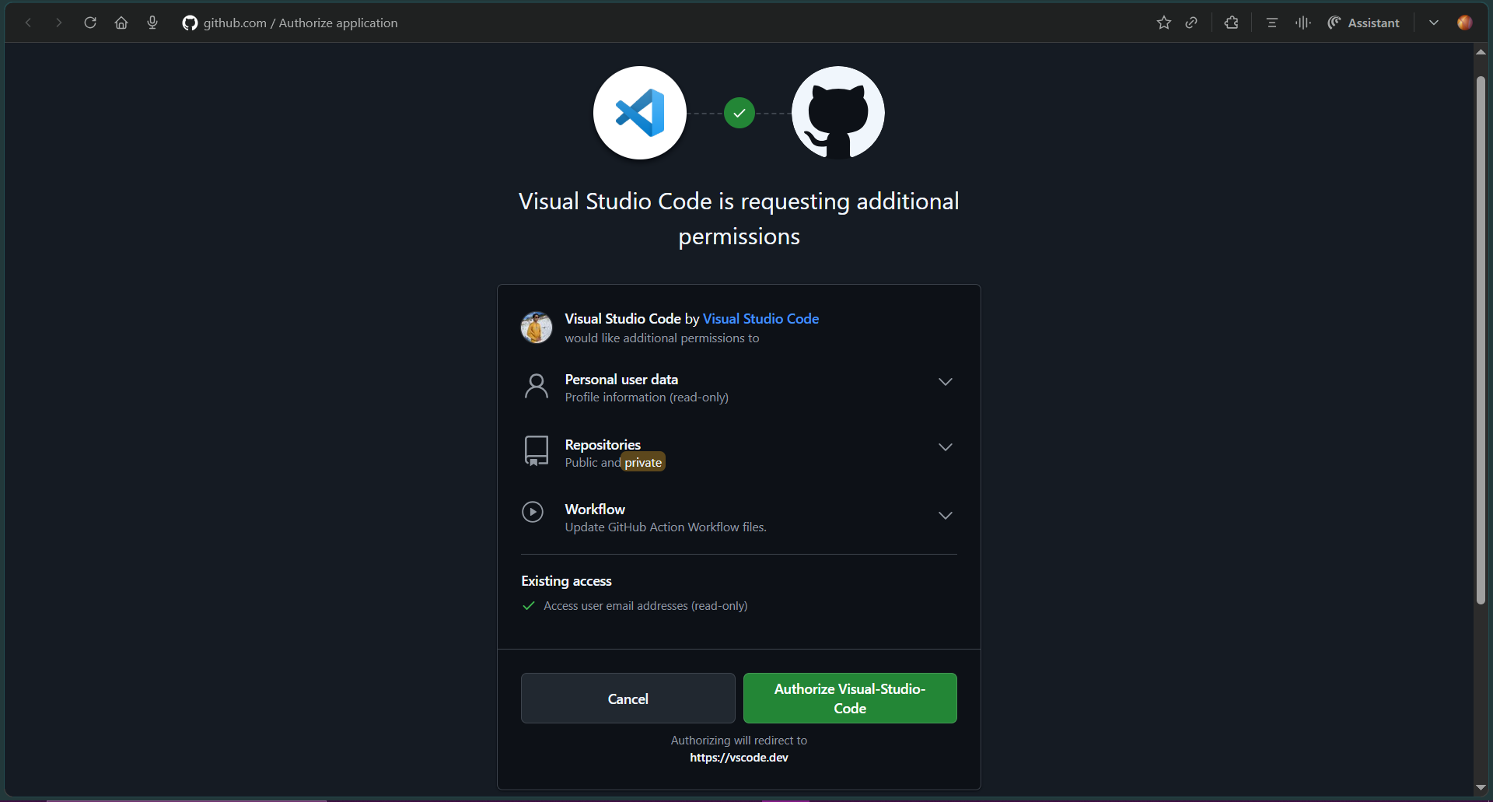
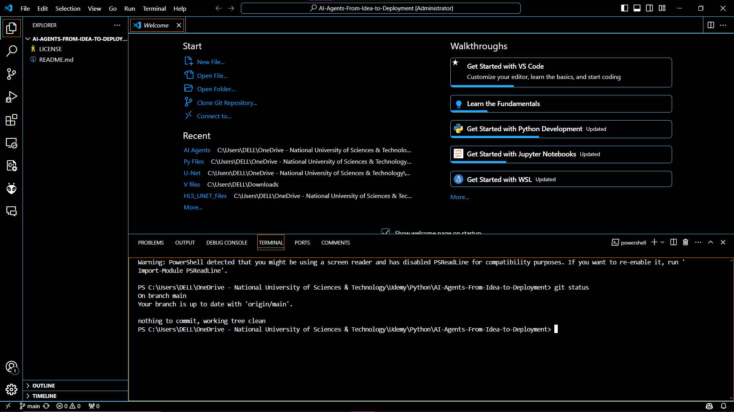
- This downloads the repo to your local computer.

Checking Repository Status
Syntax:
git status
Example:
git status
Comments:
- Shows which files are changed, added, or untracked.
- Use this before committing to see what changes are staged or unstaged.

Adding Changes
# First of all create a file in you vs code for example Python file
# Use the plus sign and create a new file with the extension name
# For Example file name is Rock-Paper-Scissors-Game and extension name is .py
# Rock-Paper-Scissors-Game.py is created now
# Write the code in your file and when It is done then commit the changes
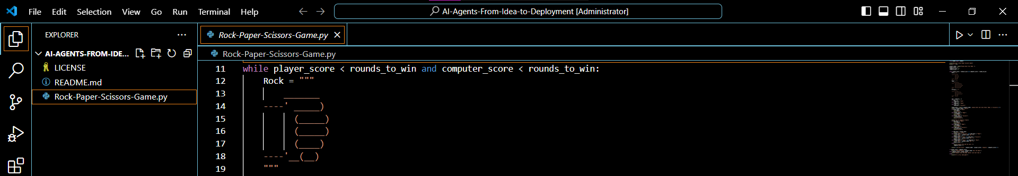
Syntax:
git add <file-name>
git add . # adds all changes
Example:
git add Rock-Paper-Scissors-Game.py # stage the new file
git add . # or stage all changes at once
Comments:
- git add prepares your changes to be committed.
- 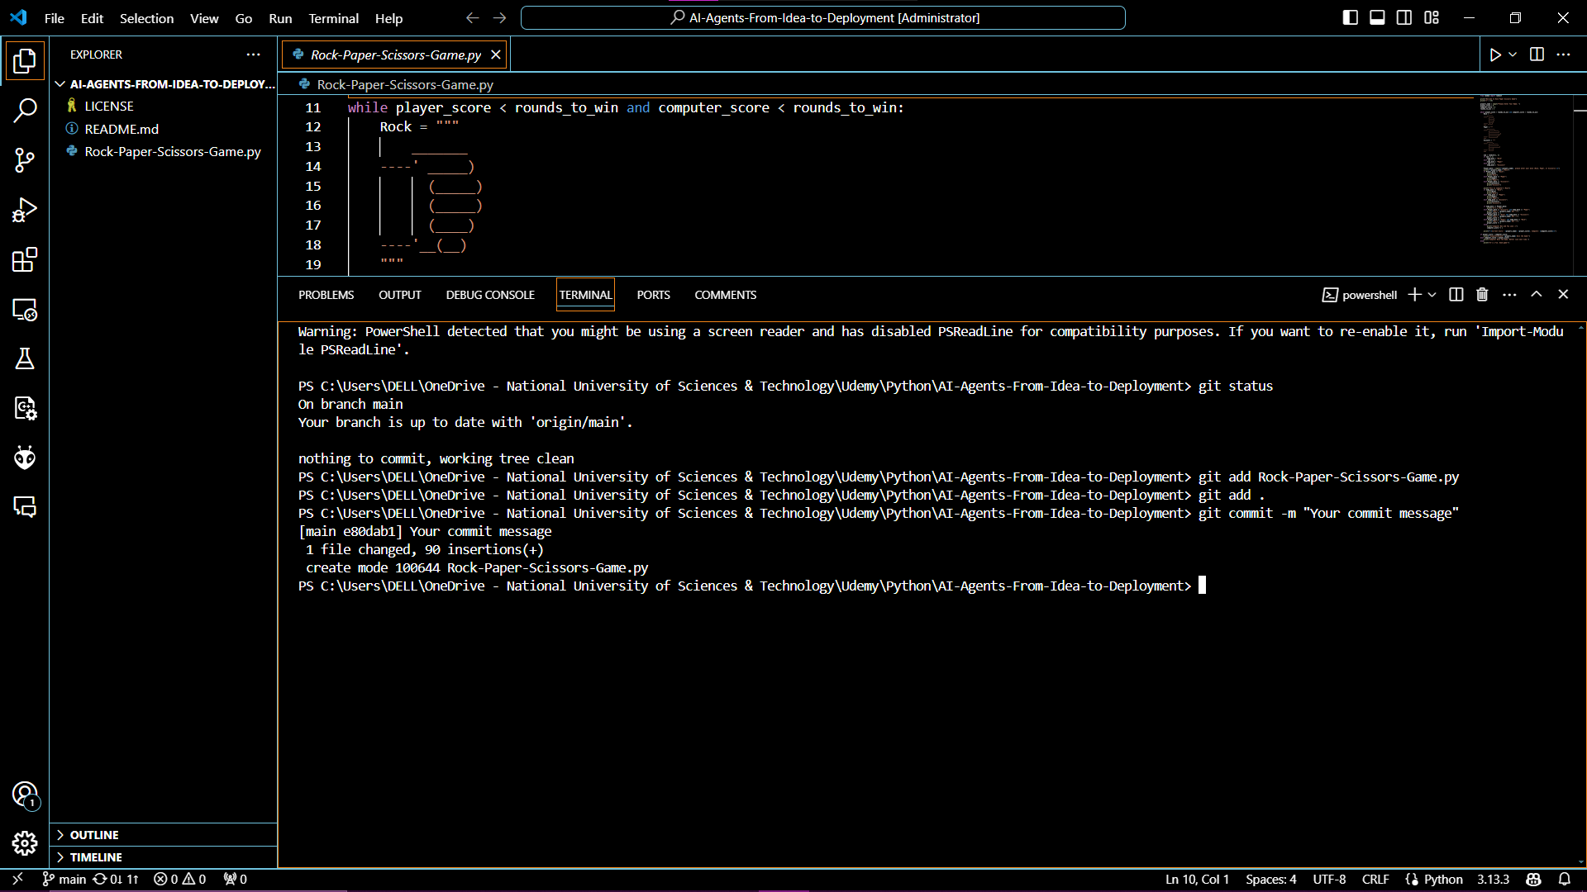

Committing Changes
Syntax:
git commit -m "Your commit message"
Example:
git commit -m "Add Rock paper scissors game python file"
Comments:
- Replace the message with a short description of your change.
- This saves the staged changes locally.

Pushing Changes to GitHub
Syntax:
git push origin <branch-name>
Example:
git push origin main
Comments:
- Sends your committed changes to the GitHub repository.
- Replace main with your branch name if working on a feature branch.

Pulling Latest Changes
Syntax:
git pull origin <branch-name>
Example:
git pull origin main
Comments:
- Updates your local repo with the latest changes from GitHub.
- Useful if someone else updated the repo.

Branching
Create a new branch (Syntax):
git branch <branch-name>
git checkout <branch-name>
Shortcut:
git switch -c <branch-name>
Example:
git switch -c add-readme # create and switch to branch named "add-readme"
Comments:
- Branches let you work on features without affecting the main code.

Merging Branches
Syntax:
git checkout main
git merge <branch-name>
Example:
git checkout main
git merge add-readme
git push origin main
Comments:
- Merge add-readme branch changes into main and push to GitHub.
Delete branch after merge (optional):
git branch -d add-readme

Quick Reference Commands Table
Command | Purpose
git config --global user.name "" | Set your Git username
git config --global user.email "" | Set your Git email
git clone <repo-url> | Download a repo locally
git status | Check which files changed
git add <file> / git add . | Stage changes for commit
git commit -m "msg" | Save changes locally
git push origin <branch> | Push changes to GitHub
git pull origin <branch> | Pull latest changes from GitHub
git branch <name> | Create a new branch
git switch -c <name> | Create + switch branch
git merge <branch> | Merge branch into current branch
git branch -d <branch> | Delete branch after merge

